Grant And revoke

- grant select on bank to c24csa54 ;

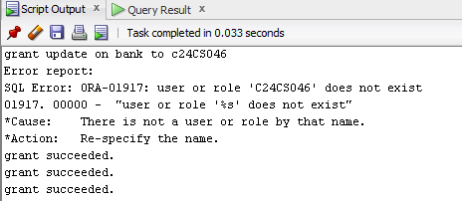

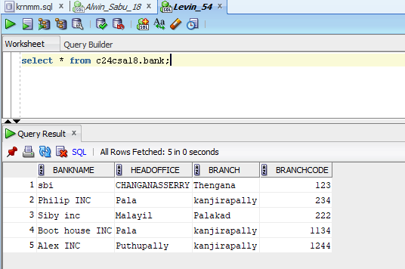

- revoke
revoke select on bank from c24csa54;

